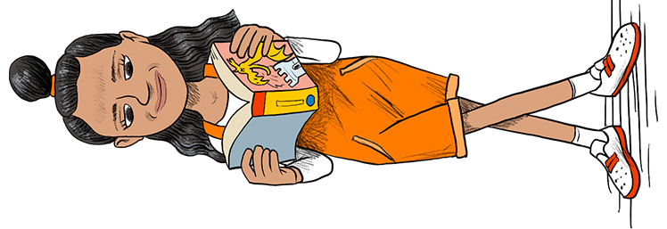

Dnevnik čitanja

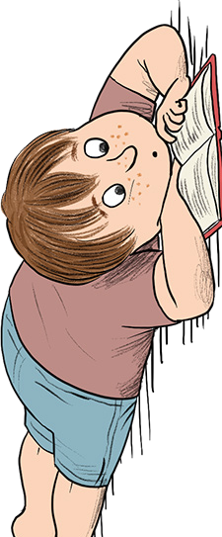
_____________________________
(ime i prezime učenika/ce)

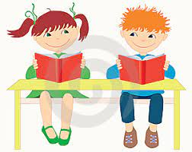

____________________________________________________________
(naziv djela)

_____________________________
(pisac)

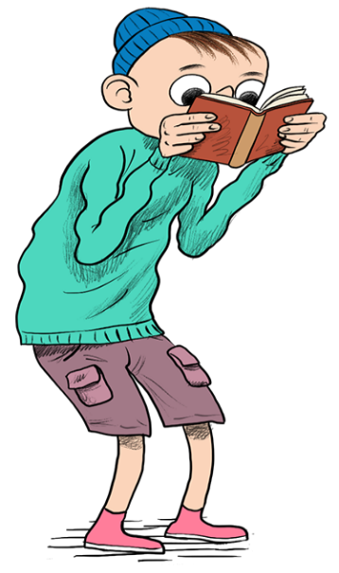

Odredi temu djela:
___________________________________________________________________________________________________________________________________.

Čemu te djelo poučilo:
___________________________________________________________________________________________________________________________________.

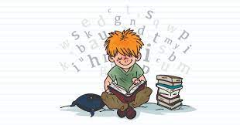

Kratko prepričaj događaj koji ti se najviše svidio.
__________________________________________________________________________________________________________________________________________________________________________________________________________________________________________________________________________________________________________________________________________________________________________________________________________________________________________________________________________________________________________________________________________________________________________.

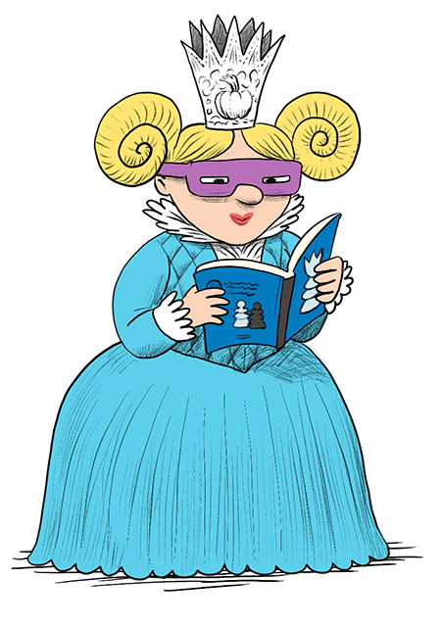

Opiši lik koji ti se najviše/najmanje svidio.
____________________________________________________________________________________________________________________________________________________________________________________________________________________________________________________________________________________________________________________________________________________________________________________________________________________________________________________________________________________________________________________________________.
Ako želiš, promijeni kraj priče.
__________________________________________________________________________________________________________________________________________________________________________________________________________________________________________________________________________________________________________________________________________________________________________________________________________________________________________________________________________________________________________________________________________________________________________________________________________________________________________________________________________________________________________________________________________________________________.
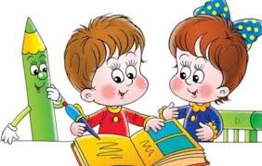

Citiraj ako želiš.
___________________________________________________________________________________________________________________________________________________________________________________________________________________________________________________________________________________________________________________________________________________________________________________________________________________________________________________________________________________________________________________________________________________________________________

Možeš nešto i nacrtati.
(ilustriraj naslovnicu ili lik, napravi skicu za plakat, putokaz, Vennov dijagram, nacrtaj ''osjećaje''…)

